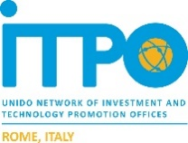
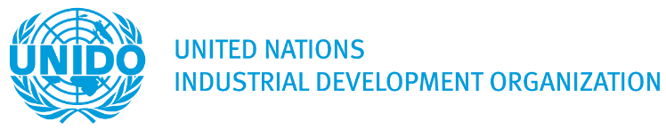

ITALIAN BUSINESS DELEGATION ON DAIRY AND LIVESTOCK
Lahore, Pakistan 24th – 26th March 2020
Proposed agenda

Three-day activities will include companies’ visits in Lahore and surrounding areas, B2B meetings, a workshop on dairy and livestock industry in Pakistanproviding a detailed presentation on the opportunities and incentives granted to foreign investors,as well as a visit to/meetings with Research Institutes/Universities.

The Italian delegation should reach Lahore on the 23rdMarch and depart on 27th March 2020. It is recommended that all the entrepreneurs will stay in the same hotel for logistic purposes.

Below a table including the main recommended meetings and visits:

24th March 2020

Pakistan Dairy Association(PDA)

Punjab Livestock & Dairy Development Board (PLDDB)

Company visits:

- Engro Foods (Lahore)
- Adam’s (Lahore)
- Usama Dairies (Khanewal – Lahore)
- Nestlé (Lahore)
- Other small companies producing milk and small plants producing cheese, ghee, yogurt, etc.
25th March 2020

Interactions/Meetings with institutions providing a detailed sectoral presentation here including the incentives for foreign direct investments.

Among others, below institutions will be involved:

Punjab Board of Investment (PBOI)
SMEDA
UVAS- University of Veterinary and Animal Science Lahore - Pakistan
TDAP/Ministry of Commerce
National Institute of Food Science and Technology (NIFSAT)

An afternoon session for B2B meetings (venue to be decided).

26th March 2020

Company’s visits:

- Yogurt and ice cream producers;
- Breeding farms (management and machineries);
- Cold chain and logistics.

